In - Direct Observation

This document is to inspire us and give us ideas based on the products available and their approaches.

Of those Ideas and inspiration, we are specifically looking for:

* How does the vehicle navigate
* Collision detection
* Learning

The Following are Product that we found that are related or similar to what our product might look like:

PikaBot

Ideas and inspiration

Sphero

Ideas and inspiration

Codey Rocky

Ideas and inspiration

Conclusion

# PikaBot

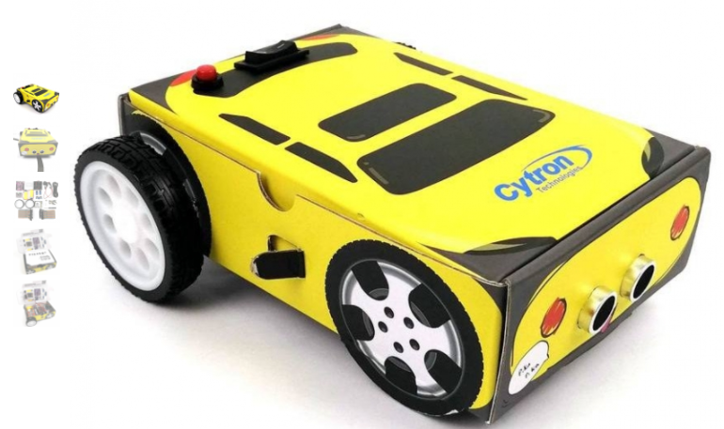

The PikaBot is a Teaching robot for young children that teaches logical thinking.

Source:

* <https://www.hackster.io/cytron-technologies/products/pikabot?ref=project-24119e>
* <https://www.hackster.io/cytron-technologies/program-arduino-mobile-robot-using-mblock-1-move-around-fd7017>

## Ideas and inspiration

* How does the vehicle navigate
  + Through a web portal (mBlock web code editor) that can input instructions to the car to behave in a certain manner or give specific instruction to the different modules (parts) of the car.
  + The Instructions are in block programming.
  + The car also has a Line following mode.
    - [https://www.youtube.com/watch?v=6CpZIe9_a](https://www.youtube.com/watch?v=6CpZIe9_a6Y)
* Collision detection
  + The Collision is the standard ultrasonic detection
* Learning
  + mBlock web code editor that uses Block coding

# Sphero

Source:

* <https://sphero.com/pages/sphero-indi>

## Ideas and inspiration

* How does the vehicle navigate
  + Through block programming
  + Cards that are placed on the floor that tells the vehicle what to do.
* Collision detection
  + No collision detection
* Learning
  + Logical thinking
    - Through cards
    - Through Block coding

# Codey Rocky

## Ideas and inspiration

* How does the vehicle navigate
  + Through block programming
  + Coloured ground , each colour would than mean different reaction depending on user coding
* Collision detection
  + No collision detection
* Learning
  + Logical thinking
    - Through cards
    - Through Block coding

# Conclusion

Honestly, When Scorowthe web for inspiration and ideas we have come to realise that most products are very similar in terms of function and capabilities. With the difference being only the quality of the hardware and the teaching method.

Thus, we have come to a few conclusions, base on the limited hardware capabilities and the user needs:

## Our Ideas and inspiration

* How does the vehicle navigate
  + Through block programming
  + Line Following or detection
* Collision detection
  + Using the Infrared sensor
  + Using the infra-red sensor to avoid or stop at the detection of a line
* Learning
  + Logical thinking
    - Through Block coding
  + Mazes
  + Pre Set up challenges both by the manufacturer(US) and created by the trainer